University of Puerto Rico, Mayagüez Campus
Electrical and Computer Engineering Department
ICOM 5047 - Computer Engineering Design Date ________________
Spring 2013

ORAL TEST "HAPPY HOUR" EVALUATION
Student's Name: ________________________________ Project Title: ________________________________
Area in the project where the student spent most of the time: ________________________________

Design
Documentation (30)
o No documentation supporting the design (-30)
o Documentation is not appropriate (not completed) (-25)
o There is documentation but it is flawed. Badly designed. (-20)
o Student presents documentation but not in a professional manner (-15)
▪ Flowcharts, class diagrams, and any other software or firmware diagrams, as well as
hardware schematics must be done using a CAD program. Hand drawn diagrams are not accepted. Must follow standards and conventions.
o If the student is designing software,
▪ he/she did not present the use case diagrams (if applicable) (-15)
▪ he/she did not present the class diagrams (if applicable) (-15)
▪ he/she did not present the sequence diagram (if applicable) (-15)
▪ he/she did not define the interfaces (if applicable) (-15) ▪ he/she did not show the flowchart (if applicable) (-15) ▪ the use case diagrams are inadequate(if applicable) (-10)
▪ the class diagrams are inadequate(if applicable) (-10)
▪ the interaction diagrams are inadequate(if applicable) (-10)
▪ the interfaces are inadequate(if applicable) (-10) ▪ the flowchart are inadequate (if applicable) (-10)
▪ the ER diagram is missing (if applicable) (-15)
▪ the ER diagram is not correct (if applicable) (-10)
o If the student is designing firmware, he/she did not show the flowchart (-15)
o If the student is designing firmware, the flowchart is inadequate (-15)
o If the student is designing hardware,
▪ he/she did not present global detailed hardware schematics (-15)
▪ he/she did not present detailed module hardware schematics (-15)
▪ he/she presented inadequate global detailed hardware schematic (-10)
▪ he/she presented inadequate detailed module hardware schematics (-10)
Specifications (30)
o Student's part does not comply with original proposal or with corresponding approved
change forms. (-30)
o Student's design does not follow proposed standards. (-20) o Student's design does not follow required standards. (-20)
o Student's has not started assembling Hardware without reasonable justification. (-20)
o Student's has not started coding Software without reasonable justification. (-20)
o The student has not evaluated different alternatives (-15)

Copyright © 2013 (Nayda Santiago, Fernando Vega, Keije Lu, Henry Estepar, January 2013)

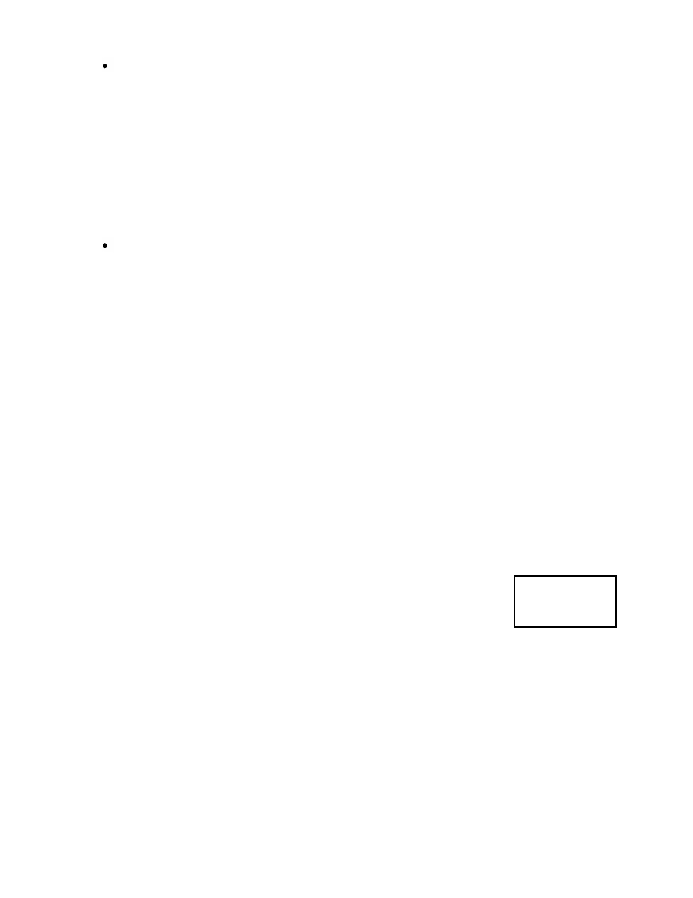Understanding (25)
o The student does not demonstrate understanding of his/her design (-25)
o The student does not demonstrate understanding of how his/her design integrates with the
whole system (-20)
o The student does not demonstrate understanding of the scope of the project (-15)
o The student cannot answer questions demonstrating proficiency in his/her part (-15)
o The student does not show knowledge required for his/her part of the design (-15)
o The student does not describe the problems associated with the design and how he/she
solved them (-10)
o The student does not know the power consumption (-10)

Proactivity (15)
o The student does not know the price or suppliers of his/her part (-15)
o The students has not ordered the parts (if justified, ok) (-10)
o The student has not kept the schedule according to the Gantt chart and there is no valid
justification of why (-10)
o If project manager, he/she has not followed the status of or maintained communication with
the group or updated Gantt chart (-10)Comments:

Contribution (Factor___________)
___Enough contribution (Multiply the total number of points by 1) ___Some contribution (Multiply the total number of points by 0.7)
___Not enough contribution (Multiply the total amount of points by 0.5)
___Not contribution (Multiply the total of points by 0.0)

H/H
Grade

Copyright © 2013 (Nayda Santiago, Fernando Vega, Keije Lu, Henry Estepar, January 2013)

