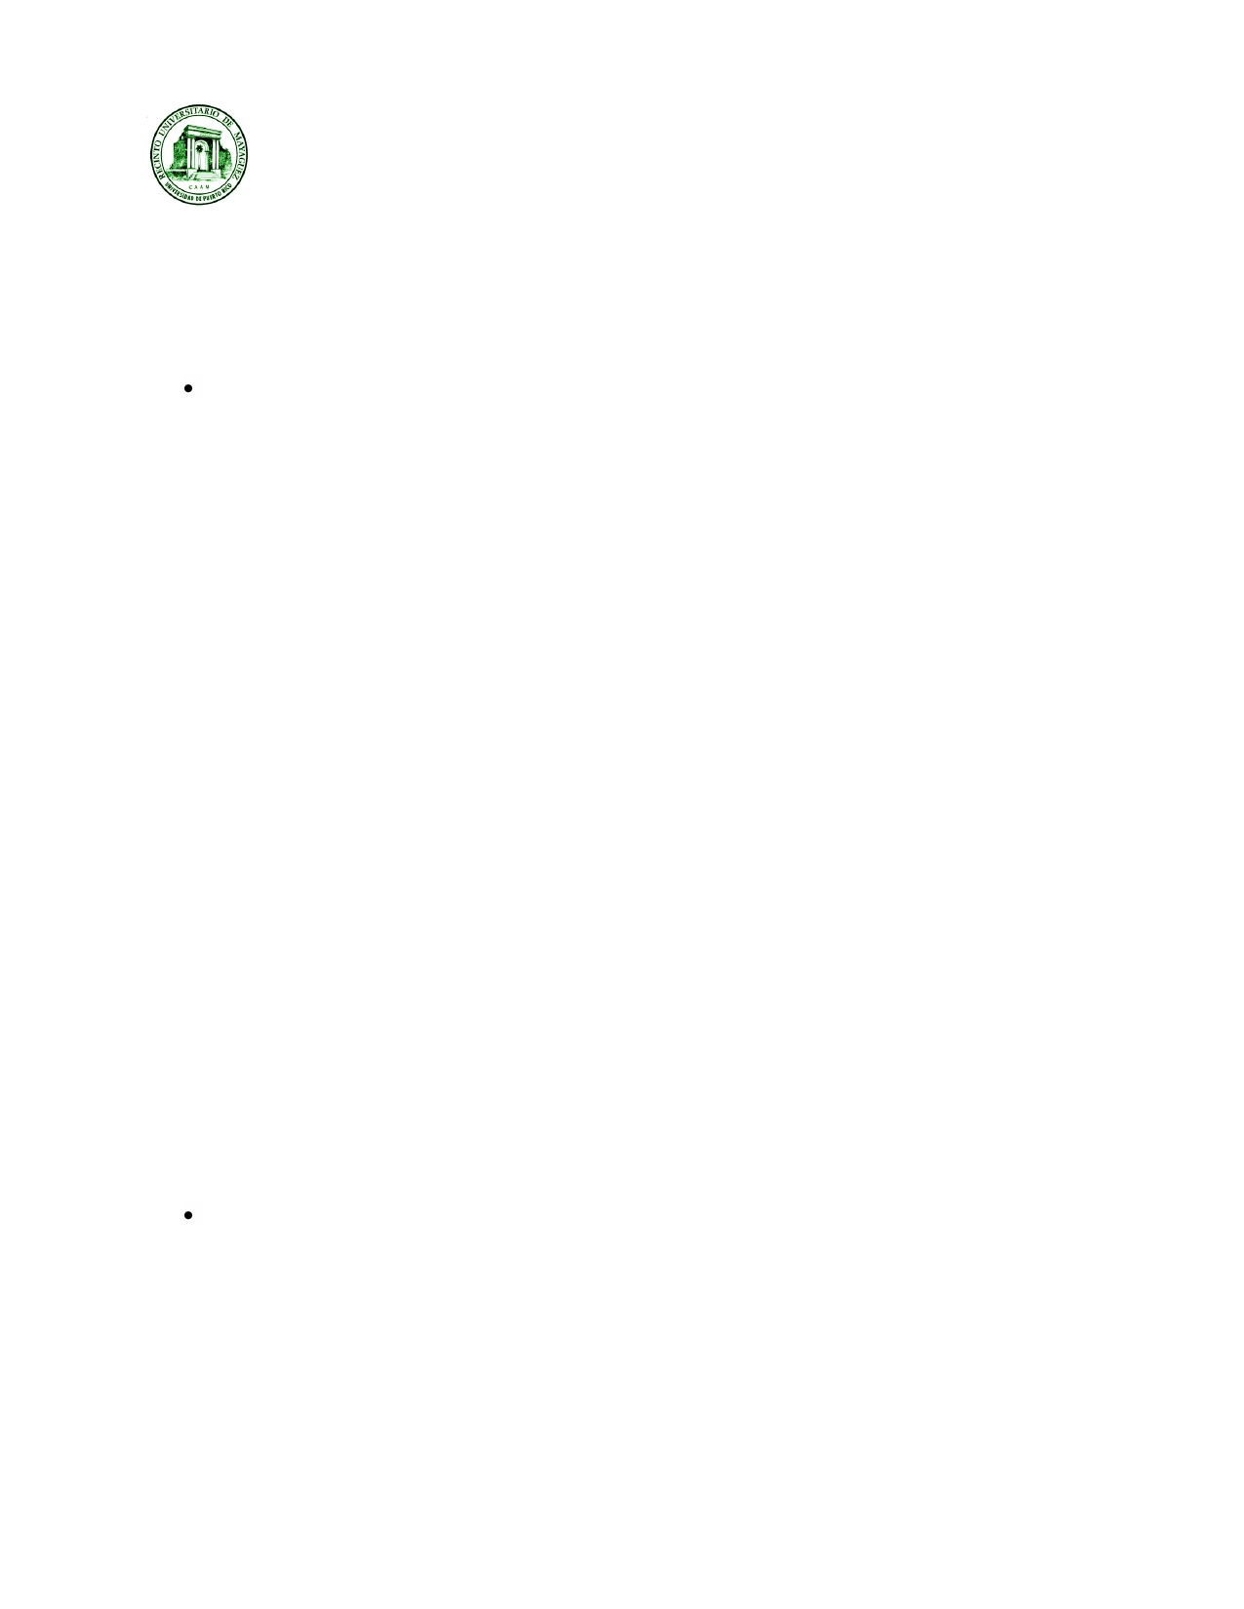**University of Puerto Rico, Mayagüez Campus**

**Electrical and Computer Engineering Department**

**ICOM 5047 - Computer Engineering Design**  Date ________________

**Spring 2014**

**ORAL TEST "HAPPY HOUR 1" EVALUATION**

Student's Name: ________________________________ Project Title: ________________________________

Area in the project where the student spent most of the time: ________________________________

Design

Documentation (30)

o No documentation supporting the design (-30)

o Documentation is not appropriate (not completed) (-25)

o There is documentation but it is flawed. Badly designed. (-20)

o Student presents documentation but not in a professional manner (-15)

▪ Flowcharts, class diagrams, and any other software or firmware diagrams, as well as

hardware schematics must be done using a CAD program. Hand drawn diagrams are not accepted. Must follow standards and conventions.

o If the student is designing software,

▪ he/she did not present the use case diagrams (if applicable) (-15)

▪ he/she did not present the class diagrams (if applicable) (-15)

▪ he/she did not present the sequence diagram (if applicable) (-15)

▪ he/she did not define the interfaces (if applicable) (-15) ▪ he/she did not show the flowchart (if applicable) (-15) ▪ the use case diagrams are inadequate(if applicable) (-10)

▪ the class diagrams are inadequate(if applicable) (-10)

▪ the interaction diagrams are inadequate(if applicable) (-10)

▪ the interfaces are inadequate(if applicable) (-10) ▪ the flowchart are inadequate (if applicable) (-10)

▪ the ER diagram is missing (if applicable) (-15)

▪ the ER diagram is not correct (if applicable) (-10)

o If the student is designing firmware, he/she did not show the flowchart (-15)

o If the student is designing firmware, the flowchart is inadequate (-15)

o If the student is designing hardware,

▪ he/she did not present global detailed hardware schematics (-15)

▪ he/she did not present detailed module hardware schematics (-15)

▪ he/she presented inadequate global detailed hardware schematic (-10)

▪ he/she presented inadequate detailed module hardware schematics (-10)

Specifications (30)

o Student's part does not comply with original proposal or with corresponding approved

change forms. (-30)

o Student's design does not follow proposed standards. (-20) o Student's design does not follow required standards. (-20)

o Student's has not started assembling Hardware without reasonable justification. (-20)

o Student's has not started coding Software without reasonable justification. (-20)

o The student has not evaluated different alternatives (-15)

Copyright © 2013 (Nayda Santiago, Fernando Vega, Keije Lu, Henry Estepar, January 2013)

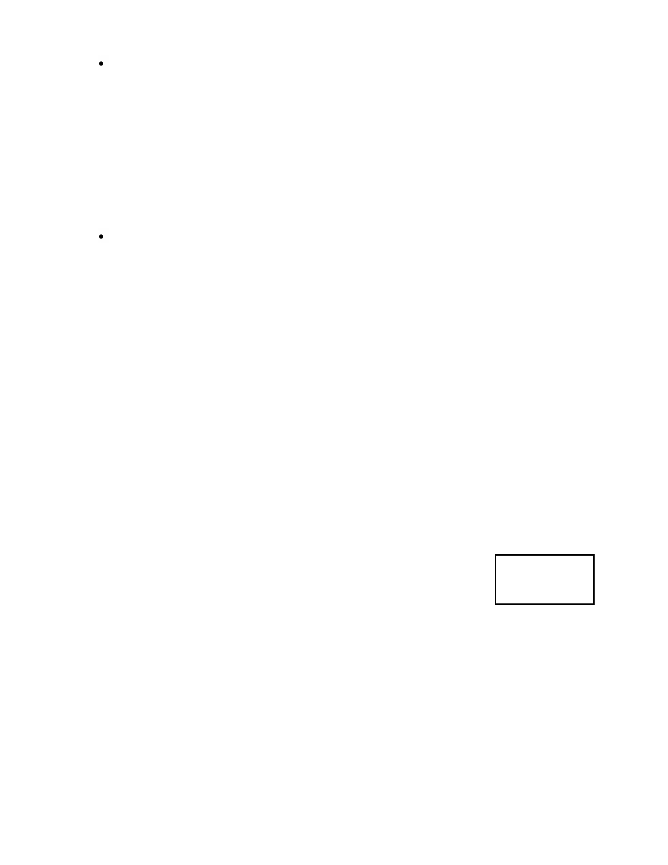Understanding (25)

o The student does not demonstrate understanding of his/her design (-25)

o The student does not demonstrate understanding of how his/her design integrates with the

whole system (-20)

o The student does not demonstrate understanding of the scope of the project (-15)

o The student cannot answer questions demonstrating proficiency in his/her part (-15)

o The student does not show knowledge required for his/her part of the design (-15)

o The student does not describe the problems associated with the design and how he/she

solved them (-10)

o The student does not know the power consumption (-10)

Proactivity (15)

o The student does not know the price or suppliers of his/her part (-15)

o The students has not ordered the parts (if justified, ok) (-10)

o The student has not kept the schedule according to the Gantt chart and there is no valid

justification of why (-10)

o If project manager, he/she has not followed the status of or maintained communication with

the group or updated Gantt chart (-10)Comments:

Contribution (Factor___________)

___Enough contribution (Multiply the total number of points by 1) ___Some contribution (Multiply the total number of points by 0.7)

___Not enough contribution (Multiply the total amount of points by 0.5)

___Not contribution (Multiply the total of points by 0.0)

H/H

Grade

Copyright © 2013 (Nayda Santiago, Fernando Vega, Keije Lu, Henry Estepar, January 2013)