Java-FFT
User’s Guide

What is Java-FFT?

The Java-FFT is a tool environment for automatic code generation of classic C languages for signal processing algorithms using Kronecker product formulations. The environment is written as a stand-alone Java application. Also a Demo version written as a Java applet to be used at the Internet is available.

About this guide

The goal of this Guided Tour is to provide easy to follow tutorial to quickly become familiar with the basic features of the environment. The tutorial contains screen shots to help you follow the step-by-step instructions.

What do you need to run the application?

In order to run the application, you must have Java 2 installed on your machine. If that is not the case, you should download the Java 2 SDK. You can download the latest version by visiting http://www.java.sun.com/.

Java-FFT Environment

When you first open the tool, it appears by default in Analysis Mode as shown in figure 1 below. In the Analysis mode the environment have compose the FFT from the parameters selected. At the topside, we have the parameters such as$N,R,S$ to one-dimensional case and the parameters $N_{1},R_{1},S_{1}$ and the parameters $N_{2},R_{2},S_{2}$ for the two-dimensional case. The user can edit these parameters through the keyboard. The composition was written in the text area provided by the application by pressing the fact button.

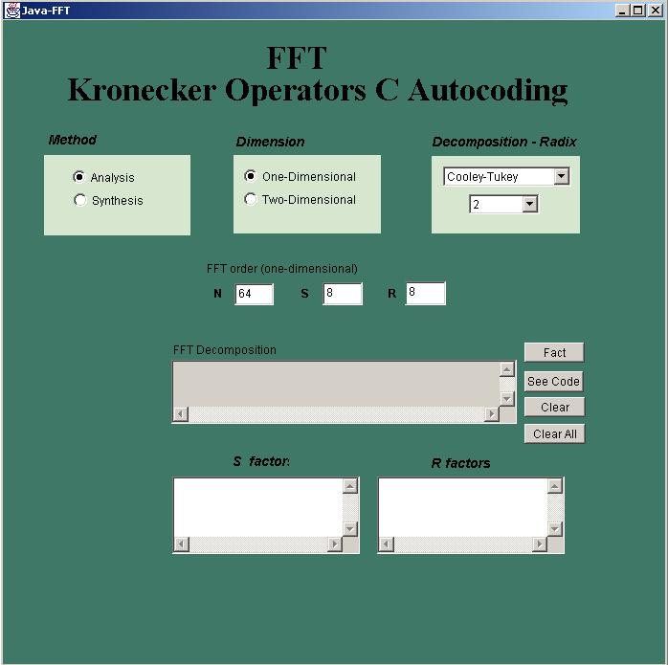
Figure 1. Default Environment
(Analysis Mode)

When you select Synthesis Method the program appears in Synthesis Mode as shown in Figure 2. In the Synthesis mode the environment have different buttons to select the desired composition for the FFT. At the topside, we have the parameters such as$N,R,S$to one-dimensional case and the parameters $N_{1},R_{1},S_{1}$ and the parameters $N_{2},R_{2},S_{2}$ for the two-dimensional case. The user can edit these parameters through keyboard. You will see the primitives operators options on the left side, to obtain the composition desired. The composition is written in the text area provided by the application.

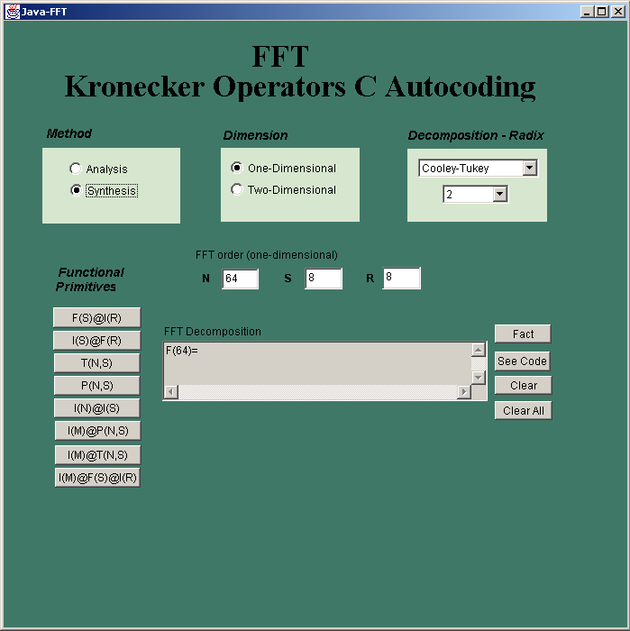
Figure 2: Environment in the Synthesis
Mode

Analysis Mode Operation

To operate in the analysis mode select the analysis method as shown in Figure 3.
In the Analysis Method the user can analyze the pre-defined Cooley Tukey decomposition.
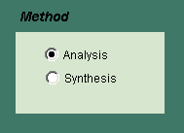
Figure 3: Analysis Method Selection

The next step in performing the operation is to select the desired dimension. You can select between two options: One or Two-dimensional data analysis. See Figure 4.

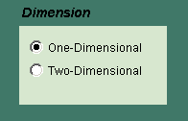
Figure 4: Dimension Selection.

If you select One-dimensional option, the environment shows one-dimensional parameters: $N,R,S$ as shown in the next figure (Figure 5). You can edit these parameters through the keyboard. When the N parameter is written in its corresponding field, press enter to set the S and R parameters.

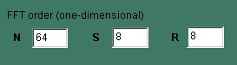
Figure 5: One-dimensional parameters: N, R, and S

If you select a Two-dimensional option, the environment shows you two-dimensional parameters:$N_{1},R_{1},S_{1}$and $N_{2},R_{2},S_{2}$ as shown in the following figure (Figure 6). You can also edit these parameters through the keyboard. Follow the same procedure as with the one-dimensional case.

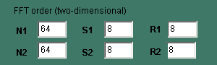
Figure 6: Two-dimensional parameters:
and

Another available option is the decomposition radix (See Figure 7). With this option you can select different radix to decompose the Cooley-Tukey decimation in time definition. The Cooley-Tukey decomposition is define as follows:
$F_{N}=(F_{S}⊗I_{R})T_{N,S}(I_{S}⊗F_{R})P_{N,S}$.
You have three different options to select.

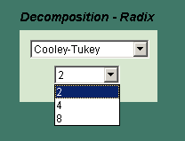
Figure 7: n-radix options

To obtain the composition press the Fact button.
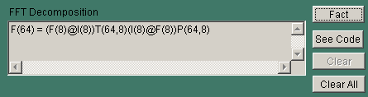
Figure 8: Obtained Composition

The Clear All button allows you to clear the text area.

After pressing the fact button you will want to obtain the c-code for the composition. To obtain it, simply press the See Code Button. When pressed, the following window will appear (Figure 9).

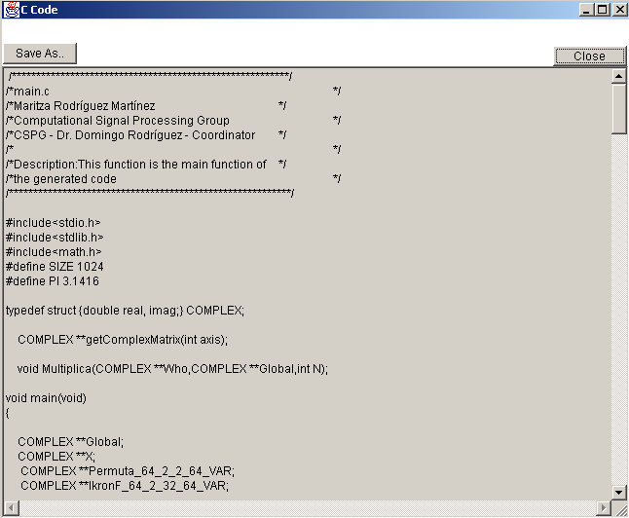
Figure 9: Generated c-code window

In this window you have two options present: to save the code or to close the window. The save option is not available on the demo version.

Synthesis Mode Operation

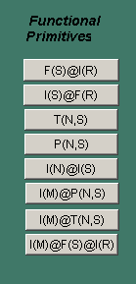
On the Synthesis Method you have the option to make your own composition using the Funtional Primitives’ buttons. Functional Primitives is a collection of buttons (see Figure 10) that with the following definitions:
Figure 10: Functional Primitives

- $F\left(R\right)⊗I\left(S\right)$ button: The button$F\left(R\right)⊗I\left(S\right)$ call the function
FkronI that performs the product between the tensor product
of matrices $F_{R}$ and $I_{S}$, where $F_{R}$ is the Fourier matrix of
order$R$, and $I_{S}$is the identity matrix of order $S$.

- $T\left(N,S\right)$ button: The button $T\left(N,S\right)$ call the function Tride
generates a vector with the elements of the main diagonal
that composes the diagonal matrix $T_{N,S}$.

- $P(\text{N,S})$button: The effect of function Permuta is equivalent
to multiply an $m$-stride permutation. This means that the
elements of $x$ will be permuted. In this function, the permutation,
that is, the $m$-stride permutation matrix is not generated.

- $I\left(N\right)⊗I\left(S\right)$ call the function IkronI that performs the product between the tensor product of the matrices $I_{N}$ and $I_{S}$, where $I_{N}$ is the identity matrix of order $N$, and $I_{S}$ is the identity matrix of order $S$. The parameter of this function are $N$and $S$.

- $I\left(M\right)⊗P\left(N,S\right)$ button: The button$I\left(M\right)⊗P\left(N,S\right)$ call the function IkronP that performs the product between the tensor product of the matrices $I_{M}$ and $P_{N,S}$, where $I_{M}$is the identity matrix of order $M$, and $P_{N,S}$ is the permutation matrix of order $S$. The parameter of this function are $M,S$ and $N$.

- $I\left(M\right)⊗T\left(N,S\right)$button: The button $I\left(M\right)⊗T\left(N,S\right)$call the function IkronT that performs the product between the tensor product of the matrices $I_{M}$ and $T_{N,S}$, where $I_{M}$ is the identity matrix of order $M$, and $T_{N,S}$ is the stride matrix of order $S$. The parameter of this function are $M,N$and $S$.

- $I\left(M\right)⊗F\left(R\right)⊗I\left(S\right)$ button: The button $I\left(M\right)⊗F\left(R\right)⊗I\left(S\right)$ call the function IkronFkI that performs the product between the tensor product of the matrices $F_{R}$ and $I_{S}$ and $I_{M}$, where $I_{M}$is the identity matrix of order $M$, and $F_{R}$ Fourier matrix of order $R$ and $I_{S}$ is the identity matrix of order $S$. The parameter of this function are $R,S$and $M$.

To operate in the synthesis mode select the synthesis method as shown in Figure 11.
In the Analysis Method the user can analyze the pre-defined Cooley Tukey decomposition.

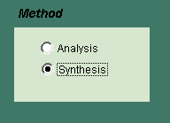
Figure 11: Synthesis Method Selection

The next step in performing the operation is to select the desired dimension. You can select between two options: One or Two-dimensional data analysis. See Figure 13.
Figure 12: Dimension Selection.

If you select One-dimensional option, the environment shows one-dimensional parameters: $N,R,S$ as shown in the next figure (Figure 5). You can edit these parameters through the keyboard. When the N parameter is written in its corresponding field, press enter to set the S and R parameters.

Figure 13: One-dimensional parameters: N, R, and S

If you select a Two-dimensional option, the environment shows you two-dimensional parameters:$N_{1},R_{1},S_{1}$and $N_{2},R_{2},S_{2}$ as shown in the following figure (Figure 6). You can also edit these parameters through the keyboard. Follow the same procedure as with the one-dimensional case.

Figure 14: Two-dimensional parameters:
and

Another available option is the decomposition radix (See Figure 7). With this option you can select different radix to decompose the Cooley-Tukey decimation in time definition. The Cooley-Tukey decomposition is define as follows:
$F_{N}=(F_{S}⊗I_{R})T_{N,S}(I_{S}⊗F_{R})P_{N,S}$.
You have three different options to select.

Figure 15: n-radix options

To select the composition simply click on the desired buttons and the composition will appear on the composition field as shown in Figure 11.
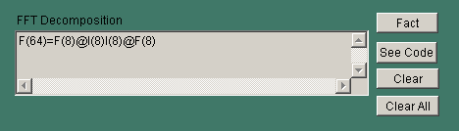
Figure 16: Obtained Composition

The Clear All button allows you to clear the text area.

After the composition is selected will want to obtain the c-code for the composition. To obtain it, simply press the See Code Button. When pressed, the following window will appear (Figure 17).

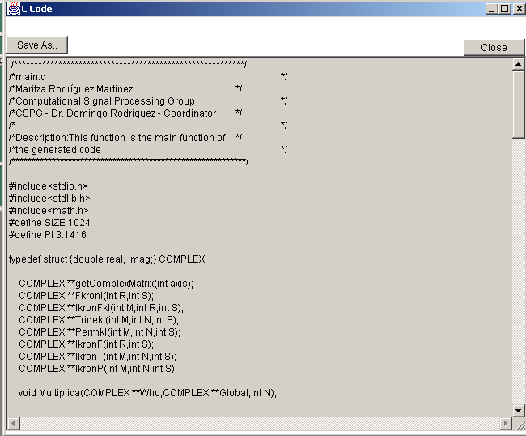
Figure 17: Generated c-code window

In this window you have two options present: to save the code or to close the window. The save option is not available on the demo version.

